R c
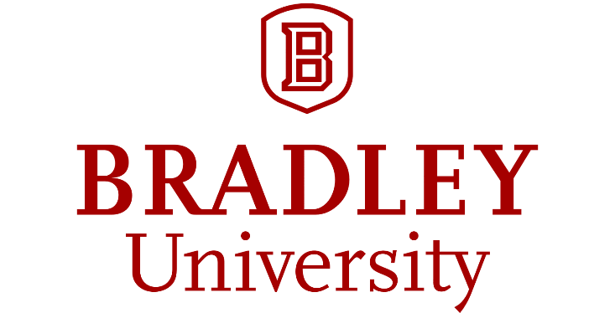
S

R

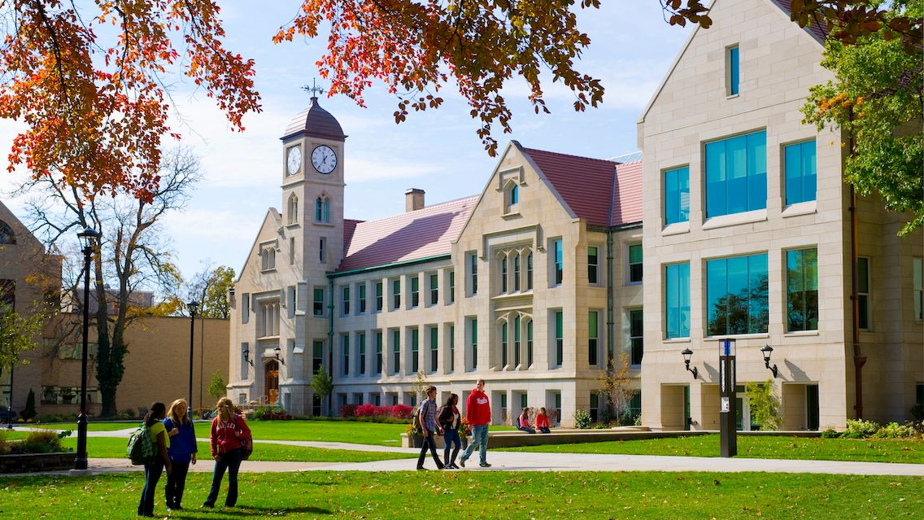 | FALL FORUM  2026  August 19, 7:30-5:00  Peplow  Pavilion

SHORT PROGRAM
BRADLEY UNIVERSITY FALL FORUM 8-20-2025 7:30 A.M. – 4:00 P.M.

Time | Session | Presentation Title | Room
7:30-8:00 a.m. |  | Check-In and Buffet Breakfast | Peplow  Pavilion
8:00-8:15 a.m.  8:15-8:30 a.m. |  | Welcome and Opening Remarks  Provost Daniel Moon and Timothy Koeltzow, CTEL Director  Update on the Mainspring Operating System  Garrett Williams | Peplow  Pavilion
8:30-10:10 a.m. | Morning  Plenary | AI at Bradley: An Interactive ZOOM Presentation by Jeff Selingo, an author and journalist addressing the subject of AI in Education | Peplow  Pavilion
Breakout Session 1  10:20-11:05 a.m. | Instructional  Technology  Teaching Excellence  Institutional Updates  Innovation & Explanation | Canvas Basics: Building a Strong Course Foundation  Taylor Long | Westlake 316A
Breakout Session 1  10:20-11:05 a.m. |  | SOTL Project Presentations  Juan Rios, John Marino, Carey Donlan, Fahmida Ashraf, and Patricia Starkey | Westlake 116
Breakout Session 1  10:20-11:05 a.m. |  | Recruiting Prospective Students: Best Practices, Insights and Challenges  Melinda Faulkner | Westlake 012
Breakout Session 1  10:20-11:05 a.m. |  | Increase Your Industry Sponsored Research: A Primer on How to Get It Done  Jim Foley, Josh Lewer, Brad Andersh, and Michelle Eaton | Westlake 110
 | Teaching & Mentoring | Cracking the Honors Code: Explaining the Honors Program and How You Can Be Involved  Jennifer Jost and Shannon Tebben-Sandoval | Westlake 010
Breakout Session 2  11:15 a.m.-  12:00 p.m. | Instructional  Technology  Teaching Excellence  Institutional Updates  Innovation & Explanation | Digitally Connected Campus and Be Connected  Emily Huschen | Westlake 316A
Breakout Session 2  11:15 a.m.-  12:00 p.m. |  | Highlighting Interdisciplinary Programs  Advancing AI Education at Bradley  Yun Wang  The Ethics Minor: Your Role in this University-Wide Program  Jason Zaborowsky | Westlake 116
Breakout Session 2  11:15 a.m.-  12:00 p.m. |  | Improving Annual Faculty Performance Reviews  Melinda Faulkner, Jacqueline Hogan,  Matthew O’Brien, and Timothy Koeltzow | Westlake 012
Breakout Session 2  11:15 a.m.-  12:00 p.m. |  | Bradley Bridge: Building A University-Wide Culture of Mentorship  Marcos Hashimoto | Westlake 110
 | Teaching & Mentoring | Online Teaching Showcase  Karin Smith and Jennifer Jost | Westlake 010
12:10 p.m. | Lunch | Sandwich & Salad Luncheon | Peplow  Pavilion
12:00-12:30 p.m. | Lunchtime Discussion | Elevating the Bradley Scholarship Experience: Scholarship Reform and a New Scholarship Management System  Angie Cooksey, Jane Walsh, Abbi Gashaw, and Andrea Wicker | Peplow  Pavilion
Breakout Session 3 | Instructional Technology | Scheduling Events and Wirelessly Connecting in Classrooms and Conference Spaces  Ken Burton | Westlake  316A
1:00-1:45 p.m. | Teaching Excellence  Institutional Updates  Innovation & Explanation  Teaching & Mentoring | What’s New in the BCC?  Robert Prescott, Alex Hertich, and Dakota Horn | Westlake 116
1:00-1:45 p.m. |  | Updates and Happenings from OIE  Anna Seghetti Gettings and Jennifer Gruening Burge | Westlake 012
1:00-1:45 p.m. |  | Strategies for Improving Access to OSP Services  Michelle Eaton, Brad Andersh, Sara Erlichman, Sangjin Ryu, Steve, Kregel, Rajesh Iyer, and Elizabeth Rosenzweig | Westlake 110
1:00-1:45 p.m. |  | Faculty Mentoring Students Mentoring Faculty: It’s All Connected!  Jana Hunzicker, Joanna Lee, Rose Aucoin, and Cecilia Hashimoto Iacoponi | Westlake 010
Breakout Session 4  1:55-2:40 p.m. | Instructional Technology  Teaching Excellence  Institutional Updates | Creative Ways to Use Canvas  Taylor Long | Westlake  316A
Breakout Session 4  1:55-2:40 p.m. |  | CTEL Spotlight: Teaching Fellows  Joseph Harris, Kristina Latva, Jennifer Jost, Yufeng Lu, and Travis Stern | Westlake  116
Breakout Session 4  1:55-2:40 p.m. |  | Get to Know Me, The Office of Campus Culture and Climate  Sonja Jordan | Westlake  012
 | Innovation & Explanation | How to Advise Students and Inspire Interest in Study Abroad  Mhairi Doty | Westlake  110
 | Teaching & Mentoring | Out With the New…In with the Old: Fostering Student Engagement by Unplugging Our Classrooms  Shannon Tevven-Sandoval | Westlake  010
2:50-3:30 p.m. | Afternoon Plenary | University Strategic Planning Committee Workshop  Dan Moon and Matt O’Brien | Peplow  Pavilion
3:30-5:00  p.m. |  | CTEL Social Hour  New Faculty Welcome  SoTL Poster Session  Cash Bar (Credit Cards Only) | Peplow  Pavilion

Bradley University Fall Forum 2026
Presentation Descriptions and Online Links if Available

Welcoming and Opening Remarks 8:00-8:30 a.m.
A Few Words from Bradley Provost, Daniel Moon and Executive Director of the Center for Teaching Excellence and Learning, Timothy Koeltzow | Peplow Pavilion

Morning Plenary 8:30-10:10 a.m.
AI at Bradley: An Interactive ZOOM Presentation by Jeff Selingo | Peplow Pavilion
Jeff Selingo is a New York Times bestselling author of four books on education and the job market, including his newest, Dream School: Finding the College That’s Right for You (2025), and past editor of The Chronicle of Higher Education. Jeff has authored two impactful white papers that will anchor his presentation at Bradley: Designing the AI University and The AI-Ready Graduate.

Breakout Session 1: 10:20-11:05 a.m.
Canvas Basics: Building a Strong Course Foundation | Westlake 316A
Taylor Long, Learning Management System Administrator, Information Technology

Whether you are new to Canvas or simply looking for a refresher, this session will help you build a strong foundation for your course. Participants will explore essential Canvas tools, including Modules, Assignments, Discussions, Quizzes, and the Gradebook, while also learning practical strategies for organizing content and communicating with students.
SoTL Presentations | Westlake 116
Juan Rios Vega, Associate Professor, Education
Carey Donlan, Assistant Professor, Physical Therapy and Health Science
Fahmida Ashraf, Associate Professor, Civil Engineering and Construction
John Marino, Associate Professor, Biology
Patricia Starkey, Assistant Professor in Residence, Physical Therapy and Health Science

These participants in the current SoTL Projects will each present 8-to-10-minute explanations of their projects and their progress on those projects.

Recruiting Prospective Students: Best Practices, Insights, and Challenges Westlake 012
https://meet.google.com/kwc-ncjg-kyg
Melinda Faulkner, Chair and Associate Professor, Biology
Mary Conway Dato-on, Executive & Academic Director, Turner School of Entrepreneurship and Innovation
Recruiting prospective students remains a key institutional priority, and this session provides an opportunity for faculty to come together and share their experiences, strategies, and insights related to building strong program enrollments. Participants will discuss effective recruitment practices as well as common challenges, with the goal of identifying actionable approaches that can strengthen efforts across departments. Key takeaways from this session will inform the Council of Chairs as it continues conversations with relevant institutional offices about enhancing recruitment support and strategy. Hosted by the Council of Chairs, this session is open to all faculty involved in student recruitment who are interested in contributing ideas, learning from colleagues, and helping shape future recruitment efforts across the university.

Increase Your Industry Sponsored Research: A Primer on How to Get It Done
Westlake 110
https://Bradley.zoom.us/j/95215886072?pwd=C0kgrVtNe1yofJmNGIrhUQr4MBjSbo.1
Jim Foley, PI, NS EPIIC Grant
Joshua Lewer, Co-PI, NSF EPIIC Grant, Interim Dean, FCB CCET
Through an NSF EPIIC grant, Bradley recently completed a GAP analysis regarding our strengths and weaknesses relating to increasing our industry-sponsored research. We had very high faculty participation and lots of enthusiasm. One finding was that faculty want to know more about the steps they need to take to get industry-sponsored research. The process tends to be easier than applying for grants, but it still involves important considerations such as IP, contracts, additional compensation, and the use of students. Join us for this discussion on how you can increase your industry-sponsored research.

Cracking the Honors Code: Explaining the Honors Program and How You Can Be Involved
https://meet.google.com/kgp-cdns-kzf
Or dial: (US) +1 601-935-4089‬ PIN: 655 656 424‬# ‬‬‬‬‬‬
Westlake 010
Jennifer Jost, Director, Honors Program, Associate Professor, Biology
Shannon Tebben-Sandoval, Assistant Director, Honors Program, Instructor in Residence, Communication

We will go over the basics of the Honors Program, including how students are admitted to Honors, the requirements to complete the program, and tips for advising students in Honors. We will also discuss opportunities for faculty/staff to increase their involvement with the Honors Program and brainstorm ways to increase student success in Honors.

Breakout Session 2: 11:15-12:00 a.m.

Digitally Connected Campus and Be Connected  https://meet.google.com/oow-pvrc-rrc | Westlake 316A
Emily Huschen, Director of Digital Innovation, Information Technology
The Digitally Connected Campus, with 5G enabled iPads and Be Connected, is how we, as a campus community, show up for students who are increasingly digital-first. Join us to learn more about the Digitally Connected Campus and Be Connected.

Highlighting Interdisciplinary Programs
Advancing AI Education at Bradley
The Ethics Minor: Your Role in this University-Wide Program
https://Bradley.zoom.us/j/5305004810?omn=94792609924
Meeting ID: 530 500 4810 Westlake 116
Yun Wang, Department Chair and Professor, Computer Science and Information
&
Jason Zaborowsky, Associate Professor, Religious Studies and Chair, Ethics Program
This session will highlight the newly launched AI Major, AI Minor, AI concentration for Computer Science (CS) and Computer Information Systems (CIS), as well as CS111, an “AI for All” course designed to broaden access to foundational AI knowledge for all Majors.
&
Please join this conversation about how you and your department can be involved in the academic study of Ethics and Ethics Program events across the University.

Improving Annual Faculty Performance Reviews
Westlake 012
https://meet.google.com/mti-sgtg-rsz
Melinda Faulkner, Chair and Associate Professor, Biology
Jacqueline Hogan, Chair and Professor, Sociology, Criminology & Social Work
Matthew O’Brien, Professor, Marketing
Timothy Koeltzow, CTEL Executive Director, Associate Professor, Psychology

Each fall, department chairs are responsible for providing written evaluations of faculty performance within their units. While this process is an important component of annual reviews, the current evaluation form has not been revised in some time and may not fully support a clear, consistent, or equitable assessment of faculty contributions. This session will bring together department chairs and program directors to discuss how faculty performance is currently evaluated across departments, including the criteria, procedures, and approaches in use. Participants will also review and critically examine the existing evaluation form, considering its strengths, limitations, and opportunities for improvement. The goal of the session is to identify ways to make the annual review process more effective, meaningful, and informative for both faculty and evaluators. Insights gathered will help guide the Council of Chairs in ongoing discussions with relevant institutional offices regarding potential revisions to the faculty performance assessment process.

Bradley Bridge: Building a University-Wide Culture of Mentorship  https://Bradley.zoom.us/j/94756144874 | Westlake 110
Marcos Hashimoto, TSE&I Managing Director • Turner School of Entrepreneurship

This interactive workshop introduces Bradley Bridge, a university-wide mentorship initiative designed to connect Bradley students with entrepreneurs, alumni, professionals, and community leaders who can support their personal, academic, professional, and entrepreneurial development. To expand access to these relationships, the Turner School of Entrepreneurship & Innovation, the Smith Career Center, and Alumni Relations have partnered to launch Bradley Bridge. Through the Startup Tree platform, students can connect with mentors, schedule meetings, document progress, and build professional relationships that complement their academic experience. Bradley faculty play a critical role in helping students identify opportunities for growth and connecting them with resources that extend learning beyond the classroom. This workshop will present examples in how faculty can assist their students.
Online Teaching Showcase
Westlake 010
https://Bradley.zoom.us/j/94155003530?jst=2

Karin Smith, Associate Professor, DNP & Graduate Program Director
Jennifer Jost, Director, Honors Program, Associate Professor, Biology
This session celebrates the exceptional work Bradley faculty have put into their online courses. Dr. Jennifer Jost will walk through Canvas item banks, including how to create them and best practices for using them in online quizzes. Dr. Karin Smith will explore how intentional course and program design can foster student engagement, scholarly dissemination, professional development, and connections to broader academic and professional communities.

Lunch 12:00 – 12:50 p.m.
Sandwich & Salad Luncheon | Peplow Pavilion

Lunchtime Discussion 12:00 – 12:30 p.m.

Elevating the Bradley Scholarship Experience: Scholarship Reform and a New Scholarship Management System | Peplow Pavilion
Angie Cooksey, Vice President for Enrollment Management and Communications
Jane Walsh, Vice President for Advancement
Abbi Gashaw, Director of Financial Assistance
Andrea Wicker, Director of Donor Relations

Learn how Bradley University is modernizing its scholarship processes through strategic reform and the implementation of a new scholarship management system. This presentation will explain how these efforts are enhancing the scholarship experience for students, donors, and campus partners.

Breakout Session 3: 1:00-1:45 p.m.
Scheduling Events and Wirelessly Connecting in Classrooms and Conference Spaces | Westlake 316A
Ken Burton, AV Services Manager, Information Technology
This session will include important skills to use in the classroom or if you schedule events. Learn how to properly schedule AV services and resources to use for your event using EMS (Event Management Software). Be sure you’ve secured the proper equipment or booked staff support by using Bradley’s event reservation system.
Next, learn how to wirelessly share content from everything from your phone to your laptop using the Ditto receiver in all classrooms and many conference spaces. Ditto was rolled out across campus a couple of years ago. If you’d like another reason to use your iPad, you want to “cut the cord” from your laptop or just want another option in case you experience an issue in your classroom, this training should help!

What’s New in the BCC?

Westlake 012

Robert Prescott, Interim Dean, College of Liberal Arts and Sciences
Alex Hertich, Professor, World Languages and Culture
Dakota Horn, Associate Provost for Academic Excellence
This will be a presentation to provide updates and new initiatives in the BCC for 2026-2027. Topics will include a new 5-year Assessment Cycle, the BCC advisement in Be Connected, the ongoing “refresh” process in the WI program, and the proposed new learning objectives in the SB and QR Areas of Inquiry.
Updates and Happenings from OIE
Westlake 012
https://meet.google.com/vpy-gjoe-ogc
Or dial: (US) +1 615-952-0640‬ PIN: 525 668 055‬#‬‬‬‬‬‬‬‬‬‬‬‬‬‬‬‬‬‬‬‬

Anna Seghetti Gettings, Institutional Effectiveness Analyst
Jenny Gruening Burge, Executive Director, Office of Institutional Effectiveness

Join the office of Institutional Effectiveness for some updates of interest for the campus community. First, we will walk through the 2026-2027 Catalog and highlight the new program filters functionality. We will highlight additional functionality, such as Course Search and catalog navigation. Second, we will provide an overview of Watermark Faculty Success functionality and an overview of the new interface, which went live in June 2026.

Strategies for Improving Access to OSP Services

https://Bradley.zoom.us/j/97978988132 Westlake 110
Michelle Eaton, Associate Director of Sponsored Programs
Brad Andersh, Director of Sponsored Programs
Sara Erlichman, Assistant Professor, Communication
Sangjin Ryu, Professor, Mechanical Engineering
Steve Kregel, Assistant Professor, Chemistry/Biochemistry
Rajesh Iyer, Chairperson, Marketing
Elizabeth Rosenzweig, Assistant Professor in Residence, Communication Sciences & Disorders
In this session, we will describe new initiatives the Office of Sponsored Programs is implementing to increase campus awareness and provide enhanced services to support grant writing, compliance, and post-award activities. New initiatives include the development of an OSP Fellows program, the launch of a pre-submission interinstitutional peer-review service, expanded webpages, increased training opportunities, and enhanced funding opportunity search capabilities. Meet the five college-based Fellows and join in an open discussion about ways OSP can better serve the campus.

Faculty Mentoring Students Mentoring Faculty: It’s All Connected!
https://Bradley.zoom.us/j/94314530841
Meeting ID: 943 1453 0841 Westlake 010
One tap mobile
+13126266799,,94314530841# US (Chicago)
+13092053325,,94314530841# US

Jana Hunzicker, Professor, Education
Joanna Lee, Assistant Professor, Education
Rose Aucoin, Assistant Professor, Counseling
Cecelia Hashimoto Iacoponi, Assistant Professor in Residence, Education

The most effective mentoring relationships benefit both mentee and mentor (Wang et al, 2025), especially when mentoring involves reciprocal sharing, scaffolding paced with the mentee’s readiness and dialogue that offers support and promotes professional growth (Swanson & Kaskey, 2022). In this way mentoring relationships become transformative. This presentation traces the development of faculty mentoring experience focused on mentoring Bradley students and collaborating on a scholarly presentation and manuscript that resulted in transformative learning for all of us.

Breakout Session 4: 1:55-2:40 p.m.
Creative Ways to Use Canvas | Westlake 316A
Taylor Long, Learning Management System Administrator, Information Technology

Canvas offers more than a place to post files and grades. In this session, discover creative and innovative ways to use Canvas to engage students, personalize learning experiences, and streamline course management. Explore features such as Lucid, Canvas Studio, Discussion Checkpoints, Differentiation Tags, and other tools that can help transform your course into a more interactive and engaging learning environment.

CTEL Spotlight: Teaching Fellows Westlake 116
Tim Koeltzow, CTEL Director, Associate Professor, Psychology
Joseph Harris, Assistant Professor Psychology
Kristina Latva, Assistant Professor, Physical Therapy and Health Science
Jennifer Jost, Director, Honors Program, Associate Professor, Biology
Yufeng Lu, Chairperson, Electrical and Computer Engineering
Travis Stern, Associate Professor Theatre Arts
Learn from participants in the program the value of inviting fellows into your classroom and consider participating in Teaching Fellows Training Opportunities.
Get to Know Me, the Office of Campus Culture and Climate

meet.google.com/nhm-yjeo-ees Westlake 012
Join by phone
(US) +1 347-384-9977‬ PIN: 833 729 395‬#‬‬‬‬‬‬‬‬‬‬‬‬ ‬‬‬‬‬‬‬‬
Sonja Jordan, Executive Director of Campus and Climate
The Office of Campus Culture and Climate is a valuable resource on the Bradley Campus. In this presentation I will share the function of my office and the ways I collaborate with faculty, staff and students.

How to Advise Students and Inspire Interest in Study Abroad Westlake 110

Mhairi K. Doty, Administrative Coordinator for Study Abroad
Study Abroud can be a transformative part of a student’s academic journey, but faculty and advisors play a critical role in helping students take the first step. This session will provide an overview of study abroad opportunities, advising best practices, and resources to help you confidently guide students toward programs that align with their academic and personal goals.

Out with the New...In with the Old: Fostering Student Engagement by Unplugging our Classrooms
Westlake 116
Shannon Tebben-Sandoval, Instructor in Residence, Communication

This session builds on a presentation I led last year introducing a pilot initiative designed to strengthen interpersonal communication in my Communication courses by limiting the use of cell phones, laptops, and tablets during class. I will share the outcomes of the program’s first year – including student feedback, lessons learned, and the impact on classroom engagement. Following the short presentation, we’ll brainstorm easy to implement strategies to encourage our students to put their phones down and talk to each other instead (Gasp!). As AI and other technologies continue to dominate the headlines around higher education, let’s take some time to focus on the value of face-to-face communication, relationship building in our classes, and getting students more engaged in the learning environment. Even if you use technology in your classrooms for instructional purposes, there may be small steps you too can take to lessen its impact.
Afternoon Plenary 2:50 to 3:30
University Strategic Planning Committee Report | Peplow  Pavilion
Dan Moon, Provost
Matthew O’Brien, Professor, Marketing
Participate in a workshop designed to translate strategic goals to measurable tactics.

Closing Activities: 3:30-5:00 p.m.
SoTL Project Posters Display  And  Social Hour | Peplow  Pavilion
There will be posters displaying current SoTL projects and a cash bar providing wine, beer and soft drinks will be available. Keep in mind the bar can only accept credit cards, not cash.

BOOK GROUPS OFFERED FOR FALL 2026

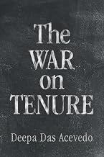

The War on Tenure by Deepa Das Acevedo
Facilitator: Jacqueline Hogan
As academia increasingly comes under attack in the United States, The War on Tenure steps in to demystify what professors do and to explain the importance of tenure for their work. Deepa Das Acevedo takes readers on a backstage tour of tenure-stream academia to reveal hidden dynamics and obstacles. She shows that tenure exists on a spectrum of comparable employment contracts, and she debunks the notion that tenure warps the incentives of professors. Ultimately, The War on Tenure demonstrates that the job security tenure provides is not nearly as unusual, undesirable, or unwarranted as critics claim.

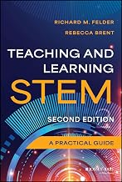

Teaching and Learning STEM: A Practical Guide by Richard M. Felder and Rebecca Brent
Facilitator: Kristi McQuade
Instructors in STEM areas need to master specific skills, such as teaching problem-solving, which are not regularly addressed in other teaching and learning books. This book fills the gap, addressing, topics like learning objectives, course design, choosing a text, effective instruction, active learning, teaching with technology, and assessment―all from a STEM perspective. This Second Edition has added chapters which have been updated to reflect recent cognitive science and empirical educational research findings that inform STEM pedagogy. You’ll also find a new section on actively engaging students in synchronous and asynchronous online courses, and content has been substantially revised to reflect recent developments in instructional technology and online course development and delivery.

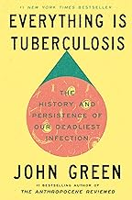

Everything is Tuberculosis by John Green
This Book Group will be meeting every other Wednesday from 2:00 to 3:00 starting September 9, 2026.
Facilitated by Liz Ward and Tehmina Pirzada
Tuberculosis has been entwined with humanity for millennia. Once romanticized as a malady of poets, today tuberculosis is seen as a disease of poverty that walks the trails of injustice and inequity we blazed for it. In Everything is Tuberculosis, John Green tells the story of Henry, a young tuberculosis patient he met in 2019 in a hospital in Sierra Leone, woven through with the scientific and social histories of how tuberculosis has shaped our world—and how our choices will shape the future of tuberculosis.
According to Amazon listing: AN ACCLAIMED BEST BOOK OF 2025: NPR, Scientific American, Science News, Booklist, BookPage, Chicago Sun-Times. Goodreads Readers’ Choice Nonfiction Winner.

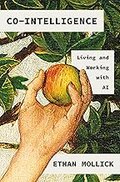

Co-Intelligence: Living and working with AI by Ethan Mollick
Facilitator: Timothy Koeltzow
Something new entered our world in November 2022 — the first general purpose AI that could pass for a human and do the kinds of creative, innovative work that only humans could do previously. Wharton professor Ethan Mollick immediately understood what ChatGPT meant: after millions of years on our own, humans had developed a kind of co-intelligence that could augment, or even replace, human thinking. Through his writing, speaking, and teaching, Mollick has become one of the most prominent and provocative explainers of AI, focusing on the practical aspects of how these new tools for thought can transform our world.
The New York Times calls this book “the definitive playbook for working, learning, and living in the new age of AI.”

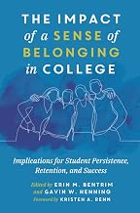

The impact of a Sense of Belonging in College by Erin Bentrim (Editor), Gavin W. Henning (Editor), Kristen A. Renn (Foreword)
Facilitated by: Taylor Soto
From the Amazon Description:
Sense of belonging refers to the extent a student feels included, accepted, valued, and supported on their campus. The developmental process of belonging is interwoven with the social identity development of diverse college students. Moreover, belonging is influenced by the campus environment, relationships, and involvement opportunities as well as a need to master the student role and achieve academic success. Over the last 10 years, colleges and universities have started grappling with the notion that their approaches to maintaining and increasing student retention, persistence, and graduation rates were no longer working. As focus shifted to uncovering barriers to student success while concurrently recognizing student success as more than solely academic. A compendium of research, applications, and approaches to sense of belonging did not exist, so the editors brought this book into being to serve as a single point of reference in an emerging and promising field of study.

